The rainbow infinity symbol is used to represent neurodiversity, which “describes the idea that people experience and interact with the world around them in many different ways; there is no one “right” way of thinking, learning, and behaving, and differences are not viewed as deficits.” The symbol is intended to reflect “diversity with infinite variations and infinite possibilities” League School is celebrating Neurodiversity by selling T-shirts and sweatshirts. Pre- order from Monday March 12th-Friday March 24th to guarantee your order.
You can order by sending back this order form or visiting the website: https://forms.gle/FKg8ysTQBxch3jJ26
Payment options:
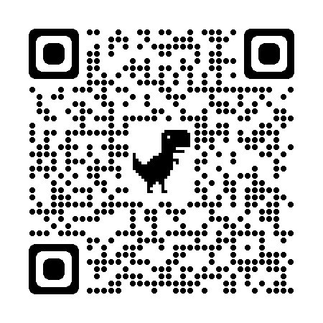
- Pay online with credit/debit card by using this QR code going to this secured link https://secure.qgiv.com/for/leagueschoolapparelorder/
- Pay via cash/ check and make payable to League School.
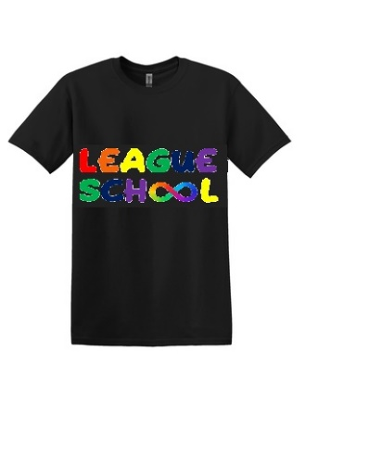
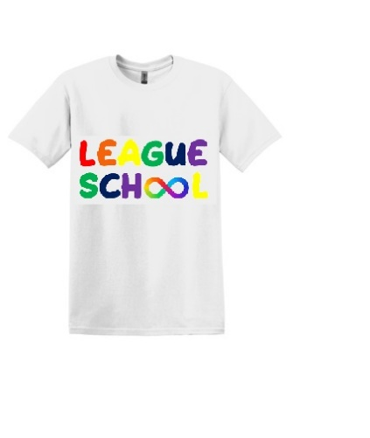
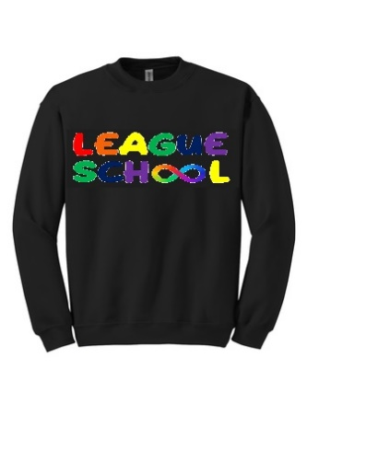
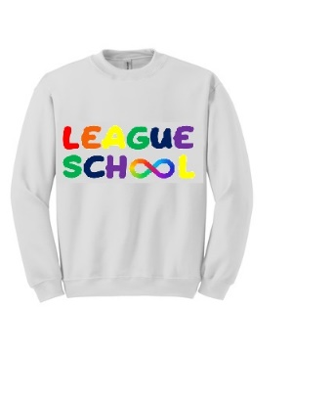
- Cash/ check can be given to Kelly Iacono in the Hawk's Nest and follow-up with her regarding your online order. (e) kIacono@leagueschool.com

White Crewneck Sweatshirt $20
Quantity: ___________
Size:______________
Name:______________________________________ Student Name:_______________________________________
Email:____________________________________________________________
Sizes include: Youth XS-XL and Adult S-5XL
Form of payment (circle one): Cash Check Online

Black Crewneck Sweatshirt $20
Quantity: ___________
Size:______________

Black T-Shirt $13
Quantity: ___________
Size:______________
White T-Shirt $13
Quantity: ___________
Size:______________

